Atitit if else 选择决策流程ast对比 sql java

表达式类型 binaryExpression hase left and rit expr

## sql

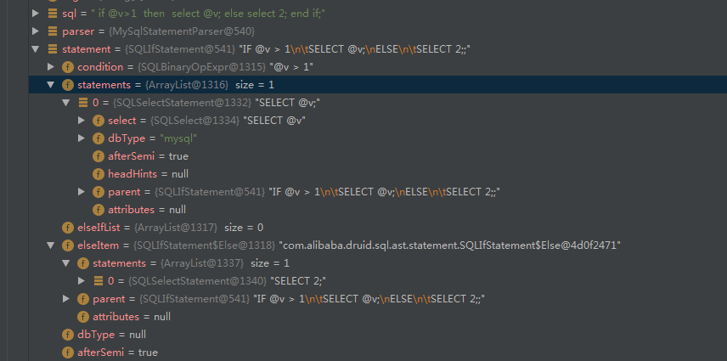

## Java

package org.codehaus.groovy.ast.stmt;  
  
import org.codehaus.groovy.ast.GroovyCodeVisitor;  
import org.codehaus.groovy.ast.expr.BooleanExpression;  
  
public class IfStatement extends Statement {  
 private BooleanExpression booleanExpression;  
 private Statement ifBlock;  
 private Statement elseBlock;

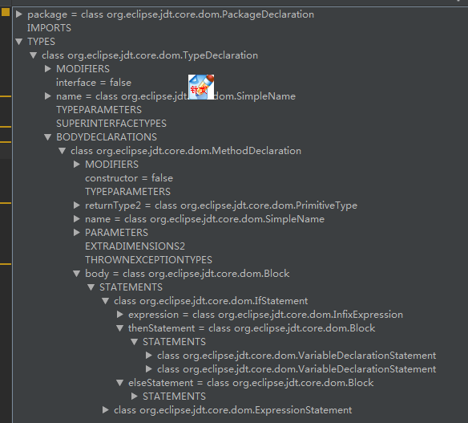

## lisp